Select one question from Question 15 through Question 17, and mark  which question you have selected on your answer sheet.
If you select two or more questions, only the first selected question will be graded.

Q15. Read the following discussion of internal design and then answer Sub-Questions 1 through 3.

Company A, a catalog company, is developing an order management system. The following is an overview of the order management process using this system.
(1) Customers fill out product order forms and then send them to Company A’s Customer Service Department. Since payment is only accepted by credit card, first-time customers write down their credit card information on the product order form. The form is shown below. A unique number for each product order form is printed in the upper right corner of the form. Up to five products can be listed on the product order form. If a customer wishes to order six or more products, they must fill out multiple order forms.

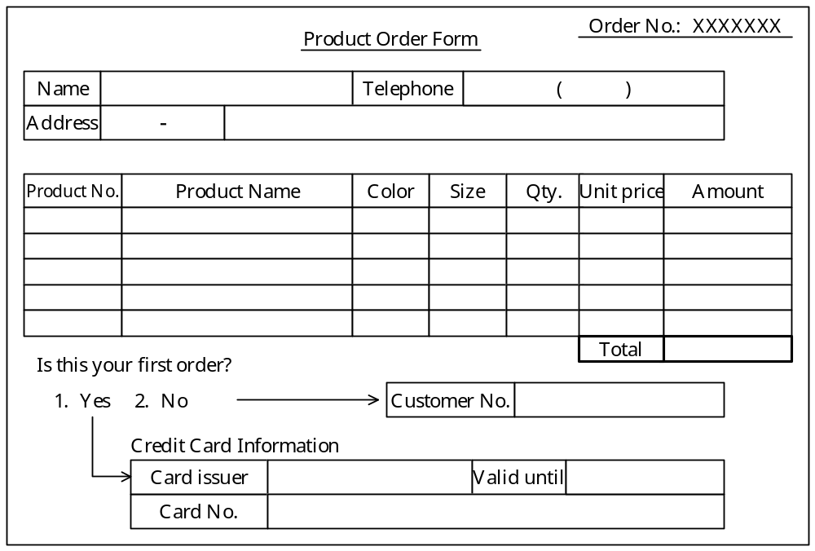
Fig. Product Order Form

(2) The Customer Service Department processes the information written on the form as follows:
① If the order is the customer first one from a, and if their credit card is written information on the form, a department clerk requests the credit card company to check the validity of the information.
② If the customer number is written on the form, a department clerk uses that number as the key for searching for the customer’s information; after making sure that the customer number is correct, a department staffer requests the credit card company to check the credit information.
③ Using the product number written on the order form as the key, a department clerk searches through the master file and makes sure that the product name, color, size and unit price are all correct. Note that if the same product comes in different colors or sizes, each size and color is given a different product number.
④ If there is any information missing from the form, or if there is an error in the information, a department clerk calls the customer. If the customer can be contacted, a department clerk fills out or corrects the necessary information and then returns the corrected order form to the customer. If no response is received from the customer, a notice (indicating that the order could not be accepted) is sent along with the order form back to the customer.
⑤ After checking the order form, the information is entered into the order management system, which stores the order.
- If the information from the order form that is stored in the order management system does not include a customer number, the order management system assigns a number automatically. If the information does include a customer number, the program calculates the discount to be applied to the current order. The amount of the discount depends on the cumulative ‘yen’ amount of product that the customer has ordered in the past, and the total amount for the current order. For example, if the cumulative order amount exceeds 50,000 ‘yen’, and the current order is for at least 3,000 ‘yen’, the customer will receive a discount of 2%.
Comment: ‘yen’ should be changed to the currency of your country.
(4) Once a day, the Product Management Department cross-checks the information in the product order forms that were received with the inventory master file and creates a delivery plan. If a given product is no longer handled, or if there will be a delay of several days before a product can be shipped, that information is recorded in the system.

Sub-Question 1
Select the correct answers to be inserted into the corresponding boxes () in the following passage from the choices provided below. In the tables in the answer groups, a “①” indicates an item that is stored in a record.

In addition to creating and managing the customer master file containing the customer information that was written on the product order forms, the Customer Service Department also creates a product order file on the basis of the product order information. The items from the product order form that must be stored in each record in the customer master file at an absolute minimum are , and the items from the product order form that must be stored in each record in the product order file at an absolute minimum are .

Answer group for a:
 | A | B | C | D | E | F | G | H | I | J
Name | ① | ① | ① | ① | ① | ① | ① | ① | ① | ①
Telephone | ① | ① | ① | ① | ① | ① | ① | ① | ① | ①
Address | ① | ① | ① | ① | ① | ① | ① | ① | ① | ①
Customer No. |  | ① | ① | ① | ① | ① | ① |  | ① | ①
Card No. |  |  | ① | ① | ① | ① | ① | ① | ① | ①
Card issuer |  |  |  | ① | ① | ① | ①
Valid until |  |  |  | ① | ① | ① | ①
Order No. |  |  |  |  | ① | ① | ① | ① | ① | ①
Product No. |  |  |  |  |  | ① | ① | ① |  | ①
Product name |  |  |  |  |  |  | ①

Answer group for b:
 | A | B | C | D | E | F | G | H | I
Name | ① | ①
Telephone | ① | ①
Address | ① | ①
Customer No. |  | ① | ① | ① | ① | ① | ① | ① | ①
Card No. |  |  | ① | ①
Card issuer |  |  | ① | ①
Valid until |  |  | ① | ①
Order No. |  |  |  | ① | ① | ①
Product No. | ① | ① | ① | ① | ① | ① | ① | ① | ①
Product name | ① | ① |  |  |  |  |  |  | ①
Qty. | ① | ① | ① | ① | ① | ① | ① | ① | ①
Unit price |  |  |  |  |  | ① |  | ① | ①
Sub-Question 2
In addition to the information written on the product order form, select what other item should be stored in the customer master file.

Answer group:
a) Cumulative ‘yen’ amount of products ordered in the past.
b) Number of inquiries made to the customer.
c) Date when inquiry was made to the customer.
d) Classification indicating that the current product order is no longer being handled.
e) Number of days before the shipment of current product order.
f) Discount for current product order.
g) Date when product order was received.
h) Discount for previous product order.

Sub-Question 3
In order to acquire new customers, Company A has begun a new discount service. First, an “introduce a friend” card is sent to Mr. X, an existing customer with a previously registered customer number. Mr. X fills out the card with Mr. Y’s information, and returns the card to the company. If Mr. Y orders a product before a certain deadline, Mr. X (who provided Mr. Y’s information) will receive an additional discount. The “introduce a friend” card provides space for information on more than one person. Assume that multiple people do not provide the same person’s information.
In order to implement this service in the system, Mr. Y is registered in the customer master file as a tentative customer as soon as Mr. X provides Mr. Y’s information to the company. Therefore, it is necessary to add an item to the customer master file that indicates whether a given registered customer is a tentative customer or not. Select THREE other items that should also be added to the customer master file:

Answer group:
a) An item for storing Mr. Y’s name in Mr. X’s record.
b) An item for storing Mr. Y’s customer number in Mr. X’s record.
c) An item for storing Mr. X’s name in Mr. Y’s record.
d) An item for storing Mr. X’s customer number in Mr. Y’s record.
e) An item for storing the discount increase.
f) An item for storing the date on which the information was registered.

Ans:
Sub 1: Ta thấy phần liên quan đến khách hàng gồm 7 thông tin gồm: Name, Telephone, Address, Customer.No, Card Issue, Valid Until, Card No. Đáp án a - D. Còn thông tin cho Product Order Form bao gồm Order.No, Customer.No, Product.No, Quality. Đáp án b – E
Sub 2: Đáp án A. Điều này ảnh hưởng đến cả customer và product order form. Vì có thể nó được dùng để xem xét lượng mua hàng của khách hàng.
Sub 3: Đáp án D, E, F. Bởi vì một người có thể giới thiệu nhiều người nên không thể điền thông tin của khách hàng Y vào thông tin của khách hàng X. Ta sẽ lưu thông tin người giới thiệu vào thông tin của khách hàng mới, cũng như số tiền sẽ được giảm nếu mua hàng.

